TPlus Newsletter

October 2025
Welcome to the October edition of the TPlus Newsletter!
We’re thrilled to share our students’ amazing achievements, staff highlights, and a peek at the creativity shining across our school in September.

Headteacher welcome
Hello TPlus family! It’s been a wonderful term full of learning, laughter, and growth. Our students continue to amaze us with their creativity, resilience, and kindness.
As we move toward the festive season, we encourage everyone to celebrate their unique achievements and continue supporting one another.
Thank you for being part of our vibrant community!

Highlights of student Achievements
This month, our students have been exploring new skills and reaching exciting milestones. From mastering new life skills to performing confidently in class presentations
and completing speaking and listening assessments each step forward is something to celebrate.
Well done, everyone!
You make Tplus shine

Staff Shoutouts
A huge thank-you to our dedicated teachers and teaching assistants who go above and beyond every day.
Special recognition this month goes to Alex and Mark who have successfully rejoined the Tplus team after some significant surgeries.
Welcome back we have missed you!

Student Artwork Gallery
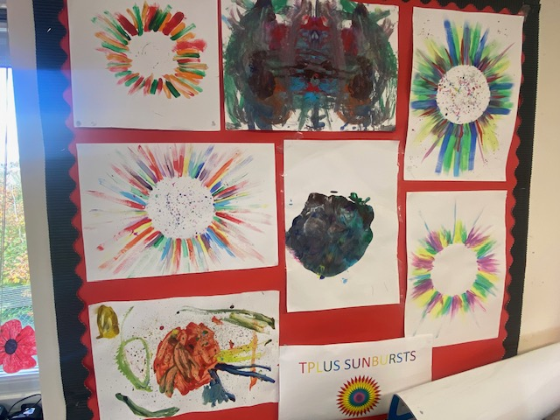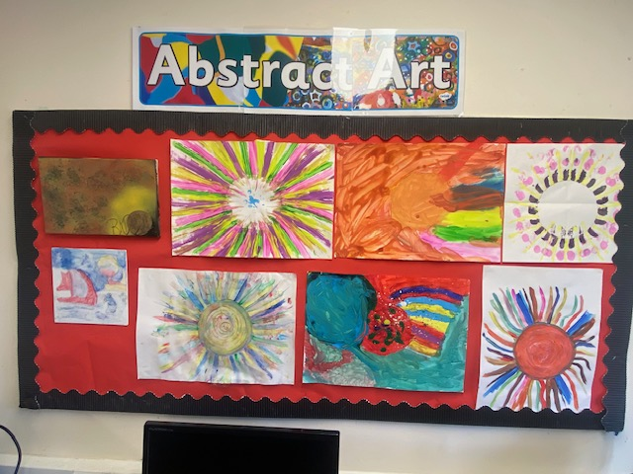o

Term Dates
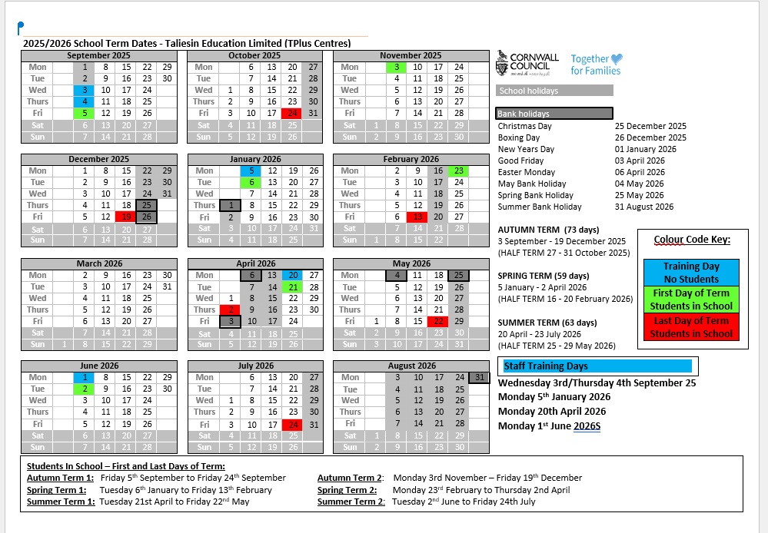

What an amazing autumn it’s been!
From golden leaves to glittery art projects, there’s been no shortage of colour and smiles.
Let’s keep that excitement going as
we head toward Christmas and all the festive fun to come!

